SIMATS ENGINEERING
ASSESSMENT TOOL 2
COURSE NAME: COMPUTER NETWORKS
COURSE CODE: CSA07
COURSE OUTCOME COVERED
CO4:
Design network topologies star, mesh, bus, and hybrid using networking devices, transmission media, and cabling standards (BL2,BL6)
Assessment Tool Weightage: 30%
Annexure A

Industry Problem-Solving Task
- A star topology is ideal for a 20-person startup because all devices connect to a central switch, making the network easy to
manage and troubleshoot. At the core sits a Layer 2/Layer 3 managed switch (such as a Cisco Catalyst or Net gear Pro Safe) with at least 24 ports to accommodate all workstations, printers, and VoIP phones with room to grow. Each device connects to the switch using Cat6 UTP cables, which support Gigabit speeds up
to 100 meters — more than sufficient for any typical office floor plan. The switch uplinks to a router/firewall (such as a Cisco RV series or pfSense appliance) that handles internet access, DHCP, and network address translation. A Wi-Fi access point connected to the switch extends wireless coverage for laptops and mobile devices. The key advantage of this design is fault isolation: if one workstation's cable fails, only that single node goes offline, leaving all other 19 employees unaffected. Centralised cable management also simplifies future moves, adds, and changes.
- A bank demands near-zero downtime, making a full or partial mesh topology the right choice. In a full mesh, every core network device — routers, core switches, and servers — connects directly to every other device, so no single link or node failure can bring down the network. For a bank, a partial mesh is typically deployed at the core layer (connecting all core switches and firewalls to each other) while the distribution and access layers use redundant uplinks to at least two core switches. Dual enterprise-grade routers (such as Cisco ASR or Juniper MX series) provide BGP-based redundant internet connectivity. All links between core devices use fiber optic cables — either singlemode for long distances between buildings or multi-mode OM4 within the data center — because fiber is immune to electromagnetic interference, supports very high bandwidth, and is essential for maintaining low-latency financial transactions. Redundant power supplies, UPS systems, and RAID storage arrays further complement the mesh design. The justification is straightforward: when a link fails in a mesh, traffic automatically reroutes through alternative paths in milliseconds using protocols like OSPF or BGP, satisfying regulatory requirements for uptime and data integrity.
- For a small classroom lab with a tight budget, bus topology offers the lowest hardware cost because all computers share a single common communication line — the bus — eliminating the need for a central switch or hub. A single coaxial cable (RG-58, 50ohm) or, in a modern variation, a single Cat5e/Cat6 cable daisychained through an inexpensive unmanaged hub runs along the length of the room. Each computer connects to the backbone using a T-connector and a BNC connector in a classic coaxial setup, with terminators (50-ohm) placed at both ends of the cable to absorb signals and prevent reflection. For a more contemporary low-cost implementation, a single inexpensive 8- or 16-port unmanaged switch replaces the terminators and uses Cat5e UTP patch cables to each workstation — achieving buslike simplicity at minimal cost. The primary limitation is that the network is susceptible to collisions and a single cable break disrupts all connected machines, but for a supervised classroom environment with light usage (internet browsing, file sharing), this trade-off is entirely acceptable. No dedicated server is required; a teacher's PC can share resources using built-in Windows/Linux file sharing.
- A large university campus serves thousands of users across multiple buildings — lecture halls, labs, libraries, dormitories, and administration — making a single topology inadequate. A hybrid topology combines the best elements of multiple designs: a fiber-based ring or mesh at the campus backbone level for redundancy, a star topology within each building for manageability, and bus or tree structures within individual labs for cost-efficiency. At the campus core, high-speed fiber optic cables (single-mode, 10 Gbps or 40 Gbps) interconnect core routers and multilayer switches using a ring or partial mesh arrangement, ensuring that no single link failure isolates an entire building. Each building has its own distribution switch connected to the campus core via dual fiber uplinks. Within each building, a traditional star topology branches from the distribution switch to floor-level access switches, which then connect individual devices via Cat6 cables. This hierarchical three-layer model — core, distribution, and access — is the industry standard for enterprise and campus networks because adding a new building simply means installing a new distribution switch and running fiber to the core, with no disruption to existing infrastructure. Wireless access points throughout the campus connect via PoE (Power over Ethernet) to access switches, eliminating the need for separate power cabling. The hybrid design thus delivers redundancy at the backbone, simplicity at the building level, and scalability campus-wide.
- Designing a network for a company with multiple departments involves creating a structured and scalable architecture using switches and routers to ensure efficient communication and security. Each department (such as HR, Finance, Sales, and IT) is connected through dedicated Layer 2 switches that form the access layer, allowing devices like computers and printers to communicate within the same department. These switches are then connected to a central Layer 3 switch or router, which acts as the core layer and enables communication between different departments through inter-VLAN routing. Virtual LANs (VLANs) are configured to logically separate each department’s network, improving security and reducing broadcast traffic. A router is also used to connect the internal network to external networks such as the internet, often with firewall functionality for security. Redundant links and backup paths can be included to ensure reliability, while proper IP addressing and subnetting are applied for efficient network management. This hierarchical design improves performance, enhances security, and allows easy expansion as the company grows.

1. Network for a 20-person startup — Star Topology
A star topology is the best choice for a 20-person startup because every computer and network device connects to a central managed switch. A 24-port Layer 2/Layer 3 switch provides enough ports for 20 employees, printers, VoIP phones, and future expansion. Each device can be connected using Cat6 UTP cable, which supports Gigabit Ethernet for distances up to 100 m.
The central switch connects to a router/firewall, which provides Internet access, DHCP, NAT, and security. A Wi-Fi access point can also be connected to the switch for laptops and mobile devices.
Advantages:
- Easy to install and manage.
- Easy to identify and troubleshoot faults.
- Failure of one cable affects only one device.
- Easy to add new computers.
- Provides good performance and scalability.
Conclusion: Star topology is suitable because it provides simple management, reliability, and easy future expansion at a reasonable cost.

2. Network for a bank — Mesh/Partial Mesh Topology
A bank requires very high reliability and minimum downtime, so a full mesh or partial mesh topology is suitable. In a full mesh, devices have multiple direct connections, while a partial mesh provides redundant connections only where they are most important.
Core routers, switches, and firewalls can have redundant links. Two enterprise routers can provide backup Internet connections. Fiber-optic cables are preferred for core connections because they provide high bandwidth, low latency, and immunity to electromagnetic interference.
Routing protocols such as OSPF or BGP can automatically select alternative paths when a link fails.
Advantages:
- High fault tolerance.
- Multiple alternative communication paths.
- Automatic traffic rerouting.
- Very high availability.
- Suitable for critical banking applications.
Conclusion: A partial mesh is generally more practical than a full mesh because it provides high redundancy without the excessive cost and complexity of connecting every device directly to every other device.

3. Small classroom lab — Bus Topology
For a small classroom with a very limited budget, a traditional bus topology can be considered because all computers share a common backbone cable. A classic implementation uses 50-ohm RG-58 coaxial cable, BNC connectors, T-connectors, and 50-ohm terminators at both ends.
However, bus topology has important disadvantages:
- A backbone cable failure can affect the entire network.
- Collisions can occur on a shared medium.
- Troubleshooting is difficult.
- Adding or removing devices can disturb the network.
For a modern classroom, an inexpensive unmanaged Ethernet switch with Cat5e/Cat6 cables is generally a better practical choice than a true bus topology.
Conclusion: Traditional bus topology has a low initial hardware cost, but star topology using a low-cost switch is normally more reliable and easier to maintain in a modern lab.

4. Large university campus — Hybrid Topology
A large university campus contains many buildings and thousands of users, so a hybrid topology is the most suitable choice. Different topology types can be used at different network levels.
A typical design is:
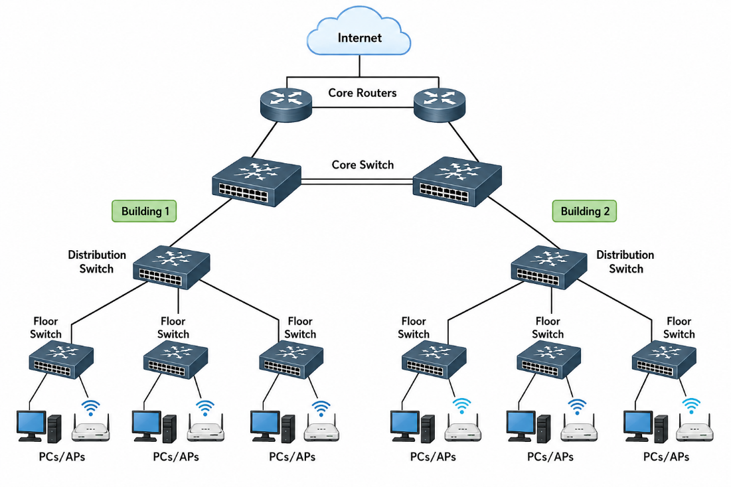
Backbone: Fiber-optic ring or partial mesh
Building level: Star topology
Floor level: Star/tree topology
Device connections: Cat6 UTP
Dual fiber uplinks provide redundancy. Wireless access points can use PoE through access switches.
Advantages:
- High scalability.
- Backbone redundancy.
- Easy management.
- Supports thousands of users.
- New buildings can be added easily.
- Faults can be isolated to specific sections.
Conclusion: Hybrid topology provides the redundancy of mesh/ring, simplicity of star, and scalability required for a large campus.

5. Company with Multiple Departments — VLAN-Based Hierarchical Topology
For a company containing departments such as HR, Finance, Sales,
and IT, a hierarchical network using VLANs, switches, and routers
is suitable.
Each department can be assigned a separate VLAN:
Department | VLAN | Example Network
HR | VLAN 10 | 192.168.10.0/24
Finance | VLAN 20 | 192.168.20.0/24
Sales | VLAN 30 | 192.168.30.0/24
IT | VLAN 40 | 192.168.40.0/24
The computers connect to Layer 2 access switches. These switches
connect to a Layer 3 core switch. The Layer 3 switch performs inter-
VLAN routing, allowing controlled communication between
departments.
A firewall/router provides Internet connectivity and security.

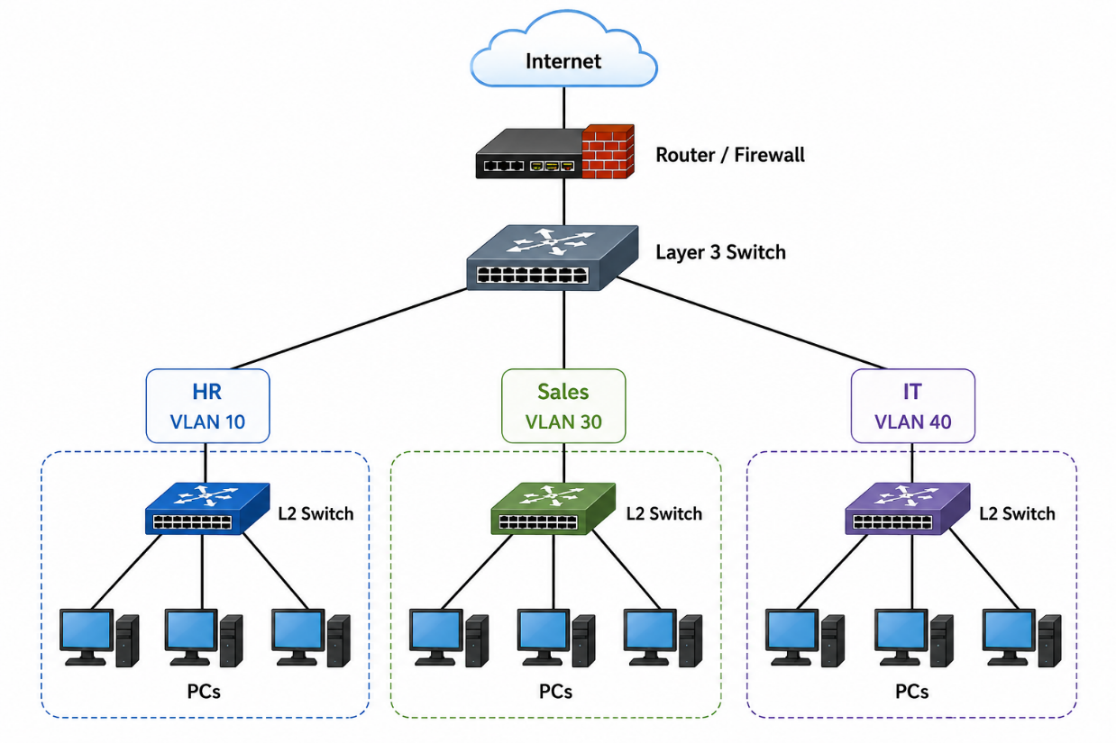
Advantages:
- Departments are logically separated.
- Improves network security.
- Reduces unnecessary broadcast traffic.
- Provides controlled inter-department communication.
- Easy to manage and expand.
- Supports redundancy and backup links.
Conclusion: A hierarchical VLAN-based design provides better
security, performance, scalability, and centralized management
for a multi-department company.

RUBRICS FOR CALCULATION
Criteria | Weightage | Exemplary (4) | Proficient (3) | Developing (2) | Beginning (1)
Problem Analysis | 15% | Clearly identifies and deeply analyzes the industry problem with all factors | Good understanding with minor gaps | Basic understanding; some key aspects missing | Poor or incorrect understanding of the problem
Solution Design | 20% | Innovative, practical, and industryrelevant solution | Effective solution with minor limitations | Partially suitable solution | Inappropriate or unclear solution
Technical  Implementation | 20% | Fully functional, accurate, and well-executed implementation | Mostly functional with minor errors | Partially implemented solution | Incomplete or non-functional implementation
Use of Tools & Technologies | 10% | Appropriate and advanced use of relevant tools and technologies | Correct use of tools | Limited or basic use of tools | Incorrect or no use of tools
Problem-  Solving  Approach | 10% | Logical, systematic, and well-structured approach | Mostly logical approach | Somewhat disorganized approach | No clear approach
Innovation & Creativity | 10% | Highly creative and original solution | Some  creativity | Limited originality | No creativity
Testing & Validation | 5% | Thorough  testing with real-world scenarios | Adequate testing | Minimal testing | No testing
Documentation & Presentation | 5% | Clear, professional, | Good documentation | Basic documentation | Poor or no documentation

 |  | and welldocumented
Teamwork /  Collaboration | 5% | Excellent coordination and contribution (if team-based) | Good  collaboration | Limited participation | No  collaboration or contribution

